**HR Dashboard MySQL-PowerBI**

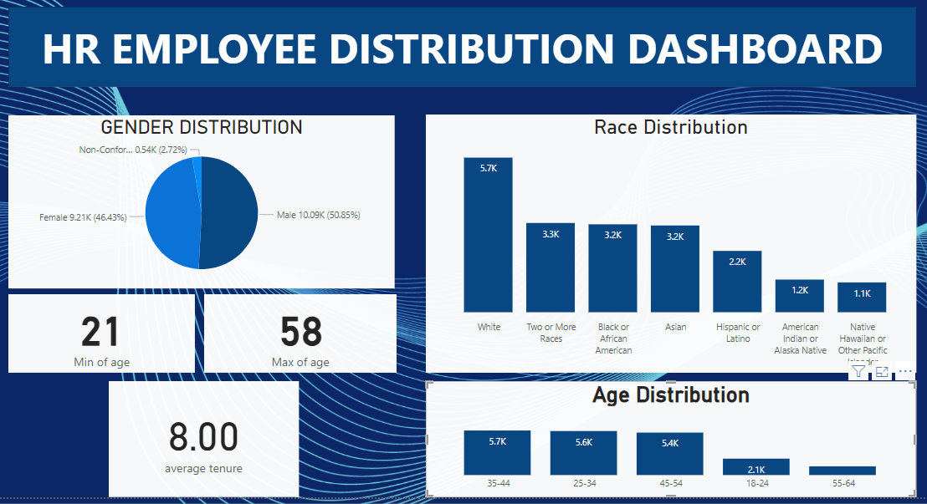

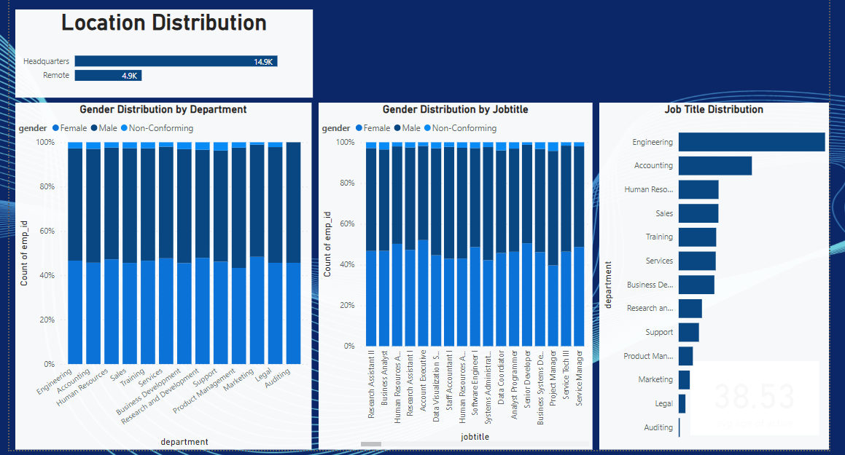

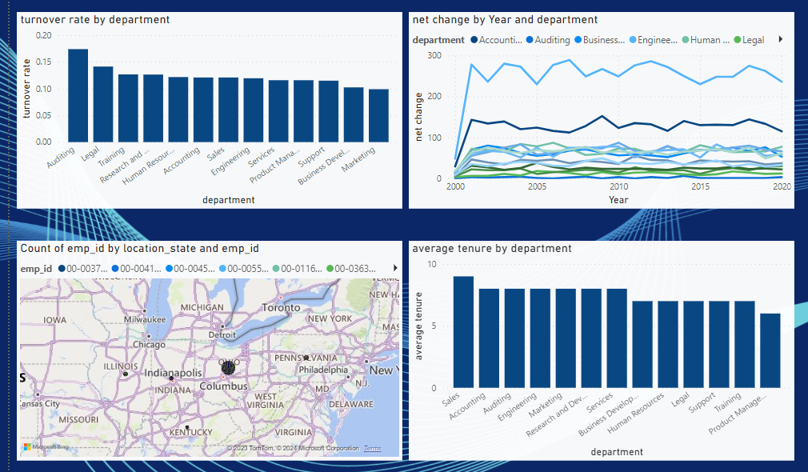

**Data Used**

**Data** - HR Data with over 19000 rows from the year 2000 to 2022 with the information about each employee’s id, name, gender, race, department, job title, birth date, age, hire data, termination date, job location.

**Data Cleaning** – Power Query Editor

**Data Analysis** – Power BI Desktop

**Data Visualization** – Power BI Desktop

**Questions**

1. What is the gender distribution of the employees in the company?
2. What is the race/ethnicity distribution of the employees in the company?
3. What is the age distribution of the employees in the company?
4. How many employees work at headquarters verses remote location?
5. What is the average length of the employment for employees who have been terminated?
6. How does the gender distribution vary across department and job titles?
7. What is the distribution of job titles across the company?
8. Which department has the highest turnover rate in the company?
9. What is the distribution of employees across locations by state?
10. How has the company’s employee count changed over the time based on hire date and termination date?
11. What is the tenure distribution for each department

**Summary of Findings**

* There are more male employees.
* White race is most dominant while Native Hawaiian and American Indian are the least dominant.
* The youngest employee is 21 years old and the oldest is 58 years old.
* 5 age groups were created (18-24, 25-34, 35-44, 45-54, 55-64). A large number of the employee are between 35-44 followed by 25-34 while the smallest group is 55-64.
* More employees are working in the headquarters compared to remote location.
* The average length of employment for terminated employees is around 8 years.
* The gender distribution across department is fairly balanced but there are generally more male than female employees.
* There are more job titles in Engineering department than any other department followed by Accounting and Research & Development. The Auditing has only one job title.
* Accounting department has the highest turnover rate followed by Legal department. The least turnover rate is in Marketing department.
* A large number of employees come from the state of Ohio.
* The net change in employees has increased over the year with maximum in the Engineering department and minimum in the Auditing department.
* The average tenure for each department is 8 years with Sales having the highest and Product Management has the lowest.